**Group 3**

**Lab Task: Bathroom Monitoring**

**Chandra Mohan Lakhinana**

Problem Statement: Detect people entry, Temperature and Humidity of Bathroom and activate exhaust as required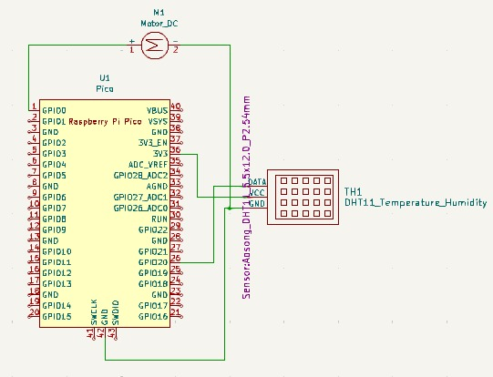

Solution: Exhaust fan is connected to an out pin 0 and output of Temperature and humidity Sensor is connected to pin 20. Pin 0 is coded to give output of Fan according to input at Pin 20 thus the Exhaust fan.

